*Open notes on*

**Real Analysis I**

*Dedicated to*

**Prof. Syed Gul Shah**

Ex Chairman, Department of Mathematics,

University of Sargodha, Sargodha, Pakistan.

***Open for use & modification***



Updated: June 29, 2024

[**⸙** Check for Update](https://www.mathcity.org/open-notes/real-analysis-i?upc=20250629)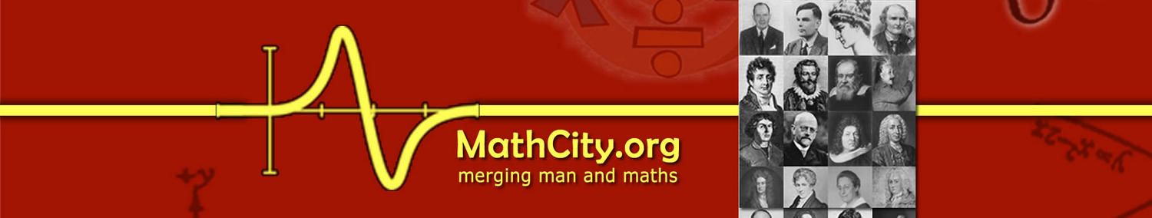

**Open Notes on Real Analysis I**

**CC BY-NC-SA 4.0 by MathCity.org**

**Created: June 29, 2025**

Available at <https://www.mathcity.org/open-notes/real-analysis-i>

**Source File:** MS Word

**Equation Editor:** Mathtype (https://www.wiris.com/en/mathtype/)

**Authors:**

* Dr. Atiq ur Rehman (COMSATS University Islamabad, Pakistan)
* Prof. Syed Gul Shah (University of Sargodha, Sargodha, Pakistan)
* Dr. Khuram Ali Khan (University of Sargodha, Sargodha, Pakistan)

Authors are individuals who make significant contributions to the content. Any new author must be approved by the first author or by at least three existing authors.

**Open Notes Auditor:**

* Ms. Marruim Izhar (Attock, Pakistan)

Open Notes Auditors are individuals who review the notes, identify errors, and report them for correction.

**Email:** [admin@mathcity.org](mailto:admin@mathcity.org)

**Facebook page:** <https://www.facebook.com/MathCity.org>

**WhatsApp Channel:** <https://whatsapp.com/channel/0029VaBuHCfGJP8IYVK71w25>

**YouTube Channel:** [www.youtube.com/@MathCityOfficial](https://www.youtube.com/@MathCityOfficial)

**Twitter:** <https://twitter.com/mathcity_org>

|  |  |
| --- | --- |
|  | These resources are shared under the licence Attribution-NonCommercial-NoDerivatives 4.0 International  <https://creativecommons.org/licenses/by-nc-nd/4.0/>  Under this licence if you remix, transform, or build upon the material, you may not distribute the modified material. |

*Open notes on*

**Real Analysis I**

**CC BY-NC-SA 4.0 by MathCity.org**

URL: [*https://www.mathcity.org/open-notes/real-analysis-i*](https://www.mathcity.org/open-notes/real-analysis-i)

Table of Contents

Real Number System 2

Sequences 15

Series 32

Limit & Continuity 48

Differentiation 59

Riemann Integrals 67

*Chapter 01*

# Real Number System

You don't have to be a mathematician to have a feel for numbers. **John Forbes Nash, Jr.**

**Historical Note:** Numbers are like blood cells in the body of mathematics. Just as the understanding of anatomy and physiology of an organic system depends much on the knowledge of blood cells, so does the understanding of mathematics depend on the knowledge of numbers. In fact, a major part of mathematics bases its development on numbers and their multifarious properties.

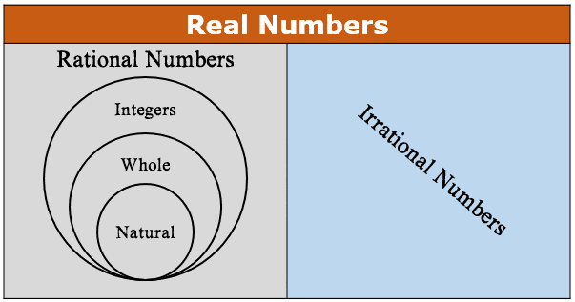It is very difficult, if not impossible, to spell out as to when did the concept of numbers came to human civilization. History, however, reveals that a formal study of numbers started almost five thousand years ago and that too by the Hindus who studied numbers purely as abstract symbols and were very proficient not only in discovering very large and very small numbers but also in using them effectively. Evidence are there that the Greek studied numbers purely on geometric conceptualization as they were very proficient in geometry and as a result had a relatively retarded progress. The greatest contribution of the Hindus is the discovery of zero, negative numbers and the decimal scale of representing numbers. In fact, they showed commendable mastery over rational numbers as early as the 5th century after Christ. The formal rigorous study of numbers, however, began even much later when mathematics faced several foundational crises. All these started in the 17th century but reached a climax after George Cantor (1845-1925) in 18th and 19th century. The contribution of 20th century in this regard is, on the one hand, stunning remarkable but on the other hand, devastating from the foundation point of view. The work and criticism by Russell (1872-1970), Lowenheim (1887-1940), Skolem (1887-1963) and Church (1903-1995) have been instrumental in bringing about a drastic change in our attitude and approach towards mathematics in general. In our modern approach, we start directly from real numbers defined axiomatically and then pass on to the related concept. (for more details see [4]). Many authors have different approach to define set of real numbers. Here we use the idea of Rudin introduced in [1].

**❖ Preliminaries**

In this section, we give some basic definitions and facts. These will help to learn and understand our main topic.

**Definition:** The set , which is usually denoted by  is called set of natural numbers.

**Definition:** The set , which is usually denoted by  is called set of integers.

**❖ Remarks:**

1. A set  can also be written as .
2. A set of positive integers is denoted by  and set of negative integers is denoted by 
3. , that is, a number 0 is neither positive nor negative.

**Definition:** Given two integers , , we say  divides  if there exists some integer  such that .

*Notation:* If  divides , then we write  and if  doesn’t divides , then we write .

*Examples:* (i) 2 divides 6, i.e.  because if and , then .

(ii) -2 divides 6, i.e.  because if and , then .

(iii) -1, 1, -*a* and *a* divide every integer *a*.

(iv) Every non-zero integer divides 0.

**Definition:** An integer is called even if it is divisible by 2, otherwise it is called odd.

*Note:* A set  represents set of all even integers and a set of odd integers is represented as .

**Definition:** A positive integer *p* is called prime if it has exactly four divisors (or two positive divisors).

*Examples:* 2, 3, 11, 29 are prime numbers.

**Definition:** A set is called set of rational numbers and it is usually denoted by .

**❖ Remarks:**

1. All the integers are rational number but there are numbers which are rational but not integer.
2. One rational number can be written as infinitely many ways e.g.  can be written as  or  or .
3. Between any two rational numbers there exist a rational number, that is, there are infinity many rational between any two rational numbers.
4. There are operations of addition (+) and multiplication () on  and , which has nice properties.
5. The set of integers is exclusively the point of interest in Number Theory.

**❖ Preparation to Define Set of Real Numbers**

It is not easy to define set of real numbers as we define  or . The real number system can be described as a “complete ordered field”. Therefore, let’s discusses and understand these notions first.

**❖ Order or Ordered Set**

**Definition:** Let *S* be a non-empty set. An *order* on a set *S* is a relation denoted by “” with the following two properties

(*i*) If , then one and only one of the statements

 , ,  is true.

(*ii*) If  and if ,  then .

*Examples:* Consider the following sets:

* 
* 
* 

There is an order on *A* and *C* but there is no order on *B* (we can define order on *B*).

**Definition:** A non-empty set *S* is said to be *ordered set* if an order is defined on *S*.

*Examples:* (i) The set ,  and  are examples of ordered set with standard order relation.

(ii) The set  and are examples of set with no order.

**❖ Bounded & Unbounded Set**

**Definition:** Let *S* be an ordered set and . If there exists a  such that  for all , then we say that *E* is *bounded above*. The number  is known as *upper bound* of *E*.

**Definition:** Let *S* be an ordered set and . If there exists a  such that  for all , then we say that *E* is *bounded below*. The number  is known as *lower bound* of *E*.

**Definition:** Let *S* be an ordered set and . A set *E* is said to be bounded if it has both upper and lower bounds. Otherwise it is said to be an unbounded.

*Examples:* (i) Consider  and .

Set of all lower bounds of .

Set of all upper bounds of .

(ii) Consider ,  and .

Set of lower bounds of *E = .*

Set of lower bounds of  = .

Set of upper bounds of *E* = .

Set of upper bounds of  = *.*

**❖ Least Upper Bound (Supremum) and Greatest Lower Bound (Infimum)**

**Definition:** Suppose *S* is an ordered set,  and *E* is bounded above. Suppose there exists an  such that

(*i*)  is an upper bound of *E*.

(*ii*) If  for , then  is not an upper bound of *E*.

Then  is called *least upper bound* of *E* or *supremum* of *E* and written as .

*Example:*Consider  and .

1. It is clear that 20 is upper bound of .
2. For  if then clearly  is not an upper bound of . Hence .

**Definition:** Suppose *S* is an ordered set,  and *E* is bounded below. Suppose there exists a  such that

(*i*)  is a lower bound of *E*.

(*ii*) If  for , then  is not a lower bound of *E*.

Then  is called *greatest lower bound* or *infimum* of *E* and written as .

*Example:*Consider  and .

1. It is clear that 5 is lower bound of .
2. For  if , then clearly  is not lower bound of . Hence .

**❖ Remarks**

* A set is unbounded if either its set of upper bounds or set of lower bounds is empty.
* Supremum is the least member of the set of upper bound of the given set.
* Infimum is the greatest member of the set of lower bound of the given set.
* If  is supremum or infimum of *E,* then  may or may not belong to *E*.
  + Let  and . Then  but  and .
  + Let ** be the set of all numbers of the form , where *n* is the natural numbers, that is,

.

Then  which is in *E*, but  which is not in *E*.

**❖ Least Upper Bound Property and Greatest Lower Bound Property**

**Definition:** A set *S* is said to have the *least upper bound property* if the followings is true

(*i*) *S* is non-empty and ordered.

(*ii*) If  and *E* is non-empty and bounded above then sup*E* exists in *S*.

**Definition:** A set *S* is said to have the *greatest lower bound property* if the followings is true

(*i*) *S* is non-empty and ordered.

(*ii*) If  and *E* is non-empty and bounded below then inf*E* exists in *S*.

*Examples:* (i) The sets  and  satisfies least upper bound property.

(ii) The set of rational numbers  doesn’t satisfy completeness axiom. Consider a set . One can prove that supremum of  doesn’t exist in  even *E* is a bounded set.

If *U* and *L* denotes the set of upper and lower bounds of E respectively, then

 and .

If  is the supremum of , then clearly .

Here, we prove there is no rational *p* such that .

Let us suppose that there exists a rational *p* such that .

This implies we can write

 where ,  & *m*, *n* have no common factor.

Then   

 is even  is even

 is divisible by 2 and so  is divisible by 4.

 is divisible by 4 and so  is divisible by 2. .

i.e.  is even  is an even

 *m* and *n* both have common factor 2.

which is contradiction because *m* and *n* have no common factor.

Hence  is impossible for rational *p*.

Finally, we conclude that the set *E*, which is bounded in  doesn’t have supremun and infimum in , hence set of rational  doesn’t satisfy the least upper bound property.

**❖ Remark**

The above property is known as *completeness axiom* or *LUB axiom* or *continuity axiom* or *order completeness axiom*.

**❖ Theorem**

Suppose *S* is an ordered set with least upper bound property, , *B* is non-empty and is bounded below. Let *L* be set of all lower bound of *B.* Then



exists in *S* and .

**Proof**

Since *B* is bounded below therefore *L* is non-empty.

Since *L* consists of exactly those  which satisfy the inequality.

 .

We see that every  is an upper bound of *L*.

This implies *L* is bounded above.

Since *S* is ordered and non-empty with least upper bound property therefore *L* has a supremum in *S*, that is,  exists in *S*.

If , then (by definition of supremum)  is not upper bound of *L*.

.

It follows that .

Thus  is lower bound of .

Now if , then  because , that is,  is not lower bound of .

this means (by definition of infumum) .

**❖ Remark**

Above theorem can be stated as follows:

An ordered set which has the least upper bound property has also the greatest lower bound property.

**❖ Field**

A set *F* with two operations called addition and multiplication satisfying the following axioms is known to be field.

**Axioms for Addition:**

(*i*) If  then . *Closure Law*

(i*i*) . *Commutative Law*

(*iii*) . *Associative Law*

(*iv*) For any ,  such that  *Additive Identity*

(*v*) For any ,  such that  +*tive Inverse*

**Axioms for Multiplication:**

(*i*) If  then . *Closure Law*

(i*i*)  *Commutative Law*

(*iii*) 

(*iv*) For any ,  such that  *Multiplicative Identity*

(*v*) For any , , , such that  *tive Inverse*.

**Distributive Law**

For any , (*i*) 

(*ii*) 

**❖ Existence of Real Field**

It is worth mentioning that  and  are completely order sets but not a field.

While  is ordered field but not satisfy completeness axiom. What about a set which satisfy all three properties, that is, *i*. ordered *ii*. field and *iii*. satisfy completeness axiom. Amazingly,  (set of real numbers) is the only set which satisfy all these properties.

**❖ Theorem:**

There exists an ordered field  which has the least-upper-bound property. Moreover  contains  (set of rational numbers) as a subfield.

**Proof**

The proof of the theorem is rather long and a bit tedious. So, we are skipping the proof, one can see it at [1, Page 17]. 🞎

**Definition:** The members of  are called *real numbers*.

**Definition:** Real numbers which are not rational are called *irrational* numbers.

**❖ Explanation about** 

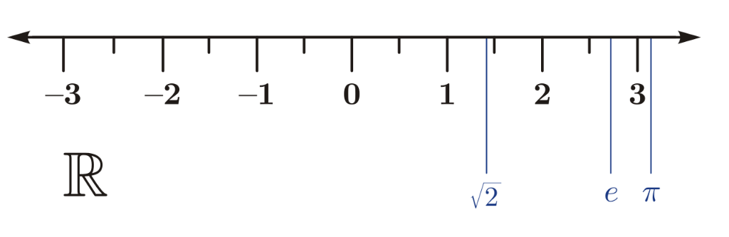 The real numbers include all the rational numbers, such as the integer −5 and the fraction 4/3, and all the irrational numbers such as  (1.41421356…, the square root of two, an irrational algebraic number) and π (3.14159265…, a transcendental number). Real numbers can be thought of as points on an infinitely long line called the number line or real line, where the points corresponding to integers are equally spaced. Any real number can be determined by a possibly infinite decimal representation such as that of 8.632, where each consecutive digit is measured in units one tenth the size of the previous one. Or a real number is a value that represents any quantity along a number line. Because they lie on a number line, their size can be compared. You can say one is greater or less than another and do arithmetic with them.

By using the fact that , the set of real numbers, is a completely order field, one can prove the following theorem.

**❖ Theorem**

Let . Then axioms for addition imply the following.

(***a***) If  then 

(***b***) If  then 

(***c***) If  then .

(***d***) 

**Proof**

(Note: *We have given the proofs here just to show that the things which looks simple must have valid analytical proofs under some consistence theory of mathematics*)

(*a*) Suppose .

Since 

 since .

 by associative law.

 by supposition.

 by associative law.

 since .



(*b*) Take  in (*a*)

 

(*c*) Take  in (*a*)

 

(*d*) Since ,

then (*c*) gives . 🞎

We are skipping the proofs of following three theorems as these may be the part of the mathematics of FSc.

**❖ Theorem**

Let . Then axioms of multiplication imply the following.

(***a***) If  and  then .

(***b***) If  and  then .

(***c***) If  and  then .

(***d***) If , then .

**❖ Theorem**

Let . Then field axioms imply the following.

(***i***) . (***ii***) if  and , then .

(***iii***) . (***iv***) .

**❖ Theorem**

Let . Then the following statements are true:

1. If  then  and vice versa.
2. If  and  then .
3. If  and  then .
4. If  then  in particular .
5. If  then .

**❖ Theorem (Archimedean Property)**

If  and  then there exists a positive integer *n* such that .

**Proof**

Let 

Suppose the given statement is false i.e. .

This implies *y* is an upper bound of *A*, that is, *A* is bounded above.

Since we are dealing with a set of real and it satisfies the least upper bound property,

Therefore supremum of *A* exists in .

Assume that .

As  so we have .

This gives  is not an upper bound of *A*.

Hence , where  for some positive integer *m*.

So, we have , where *m* + 1 is integer.

This implies .

This is impossible because  is least upper bound of *A* i.e. .

Hence, we conclude that our supposition is wrong and the given statement is true. 🞎

**❖ Theorem**

The set  of natural numbers is not bounded above.

**Proof.**

By Archimedean property in real number, for each positive real numbers , there exist  such that , that is, .

This implies, there is no positive real number  such that  for all .

This implies no real number is an upper bound of .

Hence  is not bounded above. 🞎

**❖ The Density Theorem**

If  and  then there exists  such that  .

i.e., between any two real numbers there is a rational number *or*  is dense in .

**Proof**

Let us assume that  with . Then .

By Archimedean property, for , , there exists positive integer *n* such that

,

. …………… (*i*)

Again, we use Archimedean property, for  and , , to obtain two positive integers  and  such that

 and ,

that is,

 and ,

.

Then there is an integer  such that

,

 and ,

.

Using (*i*) in the above inequality, we get



Since , it follows that



, where  is a rational.

This completes the proof. 🞎

**❖ Relatively Prime**

**Definition:** For , the numbers  and  are said to be *relatively prime* or *co-prime* if  and  don’t have common factor other than 1. If  and  are relatively prime, then we write .

**❖ Theorem**

1. If *r* is rational and *x* is irrational, then  is irrational.
2. If *r* is non-zero rational and *x* is irrational, then  is irrational.

**Proof**

(i) Suppose the contrary that  is rational. Then

, where  ,  such that ,

. ……. (1)

Since *r* is rational, there exists ,  and  such that

.

Using it in (1) to get

 , where .

As , we get *x* is rational.

This cannot happen because *x* is given to be irrational, hence we conclude that  is irrational. 🞎

(ii) Let us suppose the contrary that  is rational. Then

 for some ,  such that .

 ……. (2)

Since *r* is non-zero rational, there exists ,  and  such that

.

Using it in (2) to get

, where .

This shows that *x* is rational, which is again contradiction; hence we conclude that  is irrational. 🞎

**❖ Theorem**

Given two real numbers *x* and *y*,  there is an irrational number *u* such that

.

**Proof**

We have given , therefore .

By density theorem, for real numbers  and , we can obtain a rational number  such that





,

where  is an irrational as product of non-zero rational and irrational is irrational. 🞎

**❖ Theorem**

For every real number *x* there is a set *E* of rational number such that .

**Proof**

Take , where *x* is a real.

Then *E* is bounded above. Since  therefore supremum of *E* exists in .

Suppose .

It is clear that .

If  then there is nothing to prove.

If  then   such that ,

which cannot happen as  is the upper bound of *E*.

Hence, we conclude that real *x* is sup*E.* 🞎

**❖ Question**

Let *E* be a non-empty subset of an ordered set, suppose  is a lower bound of *E* and  is an upper bound then prove that .

**Proof**

Since *E* is a subset of an ordered set *S* i.e. .

Also  is a lower bound of *E* therefore by definition of lower bound

  …………… (*i*)

Since  is an upper bound of *E* therefore by the definition of upper bound

  …………… (*ii*)

Combining (*i*) and (*ii*)

  as required. 🞎

**❖ Question**

Show that for any two real numbers  and .

1.  (ii) .

***Note:*** Above question is proposed to know the difference between supremum & maximum.

**❖ The Extended Real Numbers**

**Definition:** The extended real number system consists of real field  and two symbols  and . We preserve the original order in  and define

.

**❖ Remarks**

It is clear that  is an upper bound of every subset of the extended real number system, and that every nonempty subset has a least upper bound. If, for example, *E* is a nonempty set of real numbers which is not bounded above in , then sup*E* =  in the extended real number system.

The same observations apply to lower bounds.

**❖ Extension of Operation in Extended Real Numbers**

The extended real number system does not form a field. But it is customary to make the following conventions:

1. If *x* is real, then

, , .

1. If  then .
2. If  then .

*Note:* (*i*) Mostly we write .

(*ii*) The above operations hold in extended real number system not in .

**❖ Euclidean Space**

**Definitions:** For each positive integer *k*, let  be the set of all ordered *k*-tuples



where  are real numbers, called the *coordinates* of .

The elements of  are called *points* or *vectors*, especially when .

If  and  is a real number, we define



and .

*Observation:* It is clear that  and . This defines addition of vectors, as well as multiplication of a vector by a real number (a scalar). These two operations satisfy the commutative, associative, and distributive laws and make  into a vector space over the real field. The *zero element* of (sometimes called the *origin* or the *null vector*) is the point  (or we simply write 0), all of whose coordinates are 0. These operations make  into a *vector space over the real field*.

**Definitions:** The *inner product* or *scalar product* of  and  from  is defined as



and the norm of  is defined by

.

**Definition:** The vector space  with the above inner product and norm is called

*Euclidean k-space* or *Euclidean space*.

**❖ Theorem**

Let  then

*i*) ,

*ii*) . (*Cauchy-Schwarz’s inequality*)

**Proof**

*i*) Since  therefore 

*ii*) If  or , then Cauchy-Schwarz’s inequality holds with equality.

If  and , then for , we have

 







Now put  (*certain real number*)

 

 ,

.

This holds if and only if

 i.e., . 🞎

**❖ Question**

Suppose , then prove that

*a*) .

*b*) .

**Solution**

*a*) Consider 

 

 .

 



 …………. (*i*)

*b*) We have 

 from (*i*) 🞎

*Chapter 02*

# Sequences

A sequence is a story told by numbers, each taking its turn in a pre-determined order. --- **Prof. Anya Sharma, Analyst**

Sequences form an important component of Mathematical Analysis and arise in many situations. The first rigorous treatment of sequences was made by A. Cauchy (1789-1857) and George Cantor (1845-1918). A sequence (of real numbers, of sets, of functions, of anything) is simply a list. There is a first element in the list, a second element, a third element, and so on continuing in an order forever. In mathematics a finite list is not called a sequence (some authors considered it finite sequence); a sequence must continue without interruption. Formally it is defined as follows:

**Sequence**

A function whose domain is the set of natural numbers and range is a subset of real numbers is called *real sequence*.

Since in this chapter, we shall be concerned with *real sequences* only, we shall refer to them as just *sequences*.

**Notation:**

A sequence is usually denoted as

 or  or  or simply as  or by .

But it is not limited to above notations only.

The values  are called the *terms* or the *elements* of the sequence .

e.g. i) .

ii) .

iii) .

iv) , a sequence of positive prime numbers.

v)  such that ,  and .

**Range of a sequence**

The set of all distinct terms of a sequence is called its range.

**Remark:**

In a sequence , since  and  is an infinite set, the number of the terms of a sequence is always infinite. However, the range of the sequence may be finite.

**Subsequence**

It is a sequence whose terms are contained in given sequence.

A subsequence of  is usually written as .

**Examples:**

1.  is subsequence of 
2.  and  is subsequence of .

**Increasing sequence**

A sequence  is said to be an increasing sequence if .

**Decreasing sequence**

A sequence  is said to be a decreasing sequence if .

**Monotonic sequence**

A sequence  is said to be monotonic sequence if it is either increasing or decreasing.

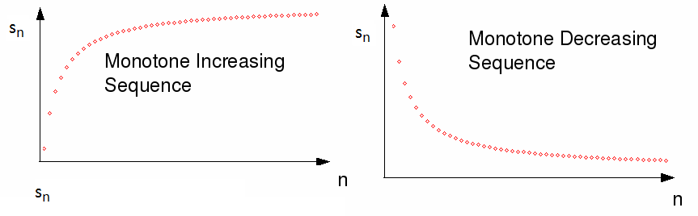

**Remarks:**

* A sequence  is monotonically increasing if 
* A positive term sequence  is monotonically increasing if , 
* A sequence  is monotonically decreasing if 
* A positive term sequence  is monotonically decreasing if , 

**Strictly Increasing or Decreasing**

A sequence  is called strictly increasing or decreasing according as

 or  .

**Examples:**

* is an increasing sequence (also it is strictly increasing).
*  is a decreasing sequence. (also it is strictly decreasing).
* is increasing sequence but it is not strictly increasing.
*  is neither increasing nor decreasing.

**Questions:**

1) Prove that  is a decreasing sequence.

2) Is  is increasing or decreasing sequence?

**Bounded Sequence**

A sequence  is said to be bounded if there is a positive number  such that

.

For such a sequence, every term belongs to the interval  Also inequality in the above definition can be replaced with strict inequality. Alternatively, a sequence is bounded if its range is a bounded set.

It can be noted that if the sequence is bounded then its supremum and infimum exist. If *S* and *s* are the supremum and infimum of the bounded sequence  then we write  and .

**Remarks:**

It is easy to conclude that if  is bounded sequence and  is positive integer then there exists  such that

 whenever .

**Examples:**

(i)  is a bounded sequence

(ii)  is also bounded sequence. Its supremum is 1 and infimum is .

(iii) The geometric sequence ,  is an unbounded above sequence. It is bounded below by *a*.

(iv)  is an unbounded sequence.

**Convergence of the sequence**

The sequence



is getting closer and closer to the number 0. We say that this sequence converges to 0 or that the limit of the sequence is the number 0. How should this idea be properly defined?

The study of convergent sequences was undertaken and developed in the eighteenth century without any precise definition. The closest one might find to a definition in the early literature would have been something like

A sequence  converges to a number L if the terms of the sequence get closer and closer to L.

However, this is too vague and too weak to serve as definition but a rough guide for the intuition, this is misleading in other respects. What about the sequence

0.1, 0.01, 0.02, 0.001, 0.002, 0.0001, 0.0002, 0.00001, 0.00002, ...?

Surely this should converge to 0 but the terms do not get steadily “closer and closer” but back off a bit at each second step.

The definition that captured the idea in the best way was given by Augustin Cauchy in the 1820s. He found a formulation that expressed the idea of “arbitrarily close” using inequalities.

**Definition**

A sequence  of real numbers is said to convergent to limit ‘*s*’ as , if for every real number , there exists a positive integer , depending on , so that

 whenever .

A sequence that converges is said to be *convergent*. A sequence that fails to converge is said to *divergent* (it will be discussed later).

We will try to understand it by graph of some sequence. Graphs of any four sequences is drawn in the picture below.

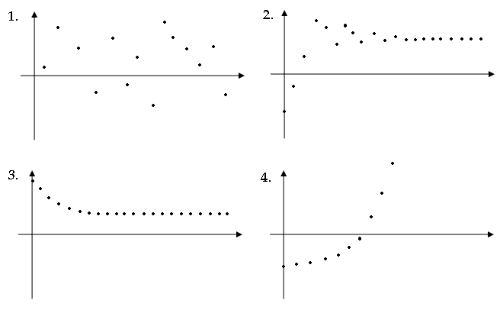

**Examples**

*a*) Prove that  (or  converges to ).

*Solution:* Let be given. By the Archimedean Property, there is a positive integer  such that , that is, . Then, if , we have

.

Thus we proved that for all , there exists , depending upon , such that

 whenever .

Hence  converges to point ‘0’.

*b*) Prove that  (by definition).

*Solution*: Let be given. Now consider

. (Since )

Now if we choose  such that  (or ), then the above expression gives us

 whenever .

Hence, we conclude that, .

*c*) Prove that  (by definition).

*Solution*: Let be given. Now consider



 ()

Now if we take  such that  (or ), then the above expression gives us

 whenever .

Hence, we conclude that .

**Questions:**

Use definition of the limits to prove the followings:

a) . b)  c) 

**Definitions**

1. A bounded sequence which does not converge is said to *oscillate finitely*.
2. A sequence  is said to be *divergent to *, if to each given positive number , there correspond an integer  such that

 for all .

1. A sequence  is said to be *divergent to *, if to each given positive number , there correspond an integer  such that

 for all .

1. A sequence  is said to *oscillate infinitely*, if it is unbounded and is divergent neither to  nor to .

**Examples**

1.  oscillates finitely.
2.  oscillates infinitely.
3.  diverges to **.
4.  diverges to .

**Question**

Prove that  diverges to  (by definition)

***Solution.***

Suppose  be given and  .

Take , i.e.   .

Now if  is positive integer such that , then

 for all .

This implies  is diverges to .

**Question**

Prove that  diverges to  (by definition).

Prove that  diverges to  (by definition).

**Review**

▪ Triangular inequality: If , then .

▪ If  for all , then .

**Theorem**

A convergent sequence of real number has one and only one limit (i.e. limit of the sequence is unique.)

*Proof:*

Suppose  converges to two limits *s* and *t*, where .

Then for all , there exists two positive integers  and  such that

  ………………. (1)

and  . ………………. (2)

As (1) and (2) hold simultaneously for all.

Thus, for all  we have





.

As  is arbitrary, we get , this gives , that is, the limit of the sequence is unique. ❑

**Theorem**

If the sequence  converges to *s*, where , then there exists a positive integer  such that  for all .

*Proof:*

Since  converges to *s*, therefore for all real , there exists positive integer  such that

 for .

We fix  to get

 for ,

that is,

 for . ………… (1)

Now



 for  (by using (1))

 for 

This ultimately gives us

 for all . ❑

**Theorem**

Let *a* and *b* be fixed real numbers if  and  converge to *s* and *t* respectively, then

(*i*)  converges to *as* + *bt*.

(*ii*)  converges to *st.*

(*iii*)  converges to , provided for all  and .

*Proof:*

Since  and  converge to *s* and *t* respectively, therefore

 

 

Also  such that   (  is bounded )

(*i*) We have





 

,

where  a certain number.

This implies  converges to *as* + *bt*.

(*ii*) 





 

, where  a certain number.

This implies  converges to *st.*

(*iii*) 

  

, where  a certain number.

This implies  converges to .

Hence  converges to .  ❑

**Question**

Prove that if , then  but converse is not true in general.

**Question**

Prove that every convergent sequence is bounded.

**Solution:**

Consider a sequence  converges to limit , that is, for all , there exists positive integer  such that

 for all .

For , we have

 for all  …….. (*i*)

Now  

Using (*i*), in above expression, we get

 for all .

Now take , then we have

 for all .

This implies  is bounded. ❑

**Review:**

* For all ,    or .

**Theorem (Sandwich Theorem or Squeeze Theorem)**

Suppose that  and  be two convergent sequences such that . If  for all , then the sequence  also converges to *s*.

*Proof:*

Since the sequence  and  converge to the same limit *s* (say), therefore for given  there exists two positive integers  and  such that

 ,

 .

i.e.  ,

 .

Also, we have given

 .

Consider , then we have

 

 

i.e.  

i.e. . ❑

**Example**

Show that .

***Solution.***

Consider



As  ,

that is,

 

 

. ❑

**Theorem**

For each irrational number *x*, there exists a sequence  of distinct rational numbers such that .

*Proof:*

Since *x* and *x* + 1 are two different real numbers, so there exist a rational number  such that



Similarly there exists a rational number  such that



Continuing in this manner we have





……………………………..........

……………………………..........

……………………………..........



This implies that there is a sequence  of the distinct rational number such that

.

Since .

Therefore

. ❑

**Theorem**

Let a sequence  be a bounded sequence.

(*i*) If  is monotonically increasing then it converges to its supremum.

(*ii*) If  is monotonically decreasing then it converges to its infimum.

**Proof**

(*i*) Let  and take .

Since there exists  such that 

Since  is monotonically increasing,

therefore

 for 

 for 

 for 



(*ii*) Let  and take .

Since there exists  such that 

Since  is monotonically decreasing,

therefore

 for 

 for 

 for 

Thus  ❑

**Questions:**

1. Let  be a sequence and . Then prove that .
2. Prove that a bounded increasing sequence converges to its supremum.
3. Prove that a bounded decreasing sequence converges to its infimum.
4. Prove that if a sequence  converges to , then every subsequence of  converges to .
5. If the subsequence  and  of sequence  converges to the same limit  then  converges to .

**Recurrence Relation**

A sequence is said to be defined *recursively* or *by recurrence relation* if the general term is given as a relation of its preceding and succeeding terms in the sequence together with some initial condition.

**Example:**

Let  and let  be defined by  for .

(i) Show that  is decreasing sequence.

(ii) It is bounded below.

(iii) Find the limit of the sequence.

Since  and  is defined by  ; 

 

Also 

 .

 .

This implies that  is monotonically decreasing.

Since  ,

 is bounded below.

Since  is decreasing and bounded below therefore  is convergent.

Let us suppose .

Then  

   

 . ❑

**Question:**

* Let  be a positive term sequence. Find the limit of the sequence if  for all 
* Let  be a sequence of positive numbers. Then find the limit of the sequence if  for .
* The Fibonacci numbers are:  , and for every ,  is defined by the recurrence relation . Find the  (this limit is known as golden number)

**Cauchy Sequence**

A sequence  of real number is said to be a *Cauchy sequence* if for given number , there exists a positive integer  such that

 

**Example**

The sequence  is a Cauchy sequence.

Suppose  and  be given. We choose a positive integer  such that .

Then if , we have  and similarly . Therefore, it follows that if , then

.

Since  is arbitrary, we conclude that  is Cauchy sequence.

**Theorem**

A Cauchy sequence of real numbers is bounded.

*Proof:*

Let be a Cauchy sequence. Then for given number , there exists a positive integer  such that

 .

Take , then we have

 .

Fix  then





 .

Now take , then we have

 for all .

Hence we conclude that is a Cauchy sequence, which is bounded one. ❑

***Remarks:***

The converse of the above theorem does not hold, that is, every bounded sequence is not Cauchy.

Consider the sequence , where , . It is bounded sequence because

 .

But it is not a Cauchy sequence if it is then for  we should be able to find a positive integer  such that  for all .

But with ,  when , we arrive at



 is absurd.

Hence  is not a Cauchy sequence. Also this sequence is not a convergent sequence.

**Questions:**

1. Prove that every Cauchy sequence of real number is bounded but converse is not true.
2. Prove that every convergent sequence is bounded but converse is not true.

**Theorem**

Every Cauchy sequence of real numbers has a convergent subsequence.

*Proof:*

Suppose  is a Cauchy sequence, therefore it is bounded.

First, we assume that  has maximum value, then set





 and so on

Then clearly  is subsequence of  and it is decreasing and bounded.

Hence it is convergent.

On the other hand, if  has no maximum value, then there exist some positive integer  such that  has no maximum value.

Now for , we can find some  such that , otherwise one of the  will be the maximum value of ..

So assume .

Now  can be the first term after  such that .

Then  can be the first term after  such that .

Continuing in this way, we get  be a subsequence of  such that it is increasing and bounded. Thus it is convergent. ❑

**Question:**

Prove that every bounded sequence has convergent subsequence.

**Theorem (Cauchy’s General Principle for Convergence)**

A sequence of real number is convergent if and only if it is a Cauchy sequence.

*Proof:*

Let  be a convergent sequence, which converges to .

Then for given   a positive integer , such that

 

Now for 



 

 .

This shows that  is a Cauchy sequence.

Conversely, suppose that  is a Cauchy sequence then for , there exists a positive integer  such that

  ……….. (*i*)

Since  is a Cauchy sequence,

therefore it has a subsequence  converging to *s* (say).

This implies there exists a positive integer  such that

  ……….. (*ii*)

Now





 ,

this shows that  is a convergent sequence. ❑

**Example**

Prove that  is divergent sequence.

Let  be defined by

.

For ,  we have



 ( times)

 = .

In particular if  then

.

This implies that  is not a Cauchy sequence therefore it is divergent. ❑

**Theorem (Nested intervals)**

Suppose that  is a sequence of the closed interval such that  ,  , and  as  then  contains one and only one point.

*Proof:*

Since , therefore

.

Note that  is increasing sequence, bounded above by  and bounded below by . Also note that  is decreasing sequence bounded below by  and bounded above by .

This implies both  and  are monotone and bounded sequences and hence convergent.

Suppose  converges to *a* and  converges to *b*.

But 

  as .

 

and  .

This given , that is,  contains only one point. ❑

**Limit inferior of the sequence**

Suppose  is bounded below then we define limit inferior of  as follow

, where .

If  is not bounded below then we define

.

**Limit superior of the sequence**

Suppose  is bounded above then we define limit superior of  as follow

, where 

If  is not bounded above then we define

.

**Remarks:**

1. *Limit inferior* is also known as *lower limit* and *limit superior* is also known sas *upper limit* of the sequence in the literature with the notations  and  respectively.
2. A bounded sequence has unique limit inferior and superior.
3. It is easy to prove that limit inferior is less than or equal to limit superior.

**Examples**

(i) Let , then limit superior of  is 1 and limit inferior of  is .

(*ii*) Let 

then limit superior of  is 1 and limit inferior of  is .

(*iii*) Let .

Then 





.

Also 



. ❑

**Theorem**

If  is a convergent sequence, then



*Proof:*

Let  then for a real number , there exists a positive integer  such that

 whenever .

i.e.  whenever . …………… (i)

If we take  and , then (i) gives us

 whenever .

This gives  and 

that is, . ❑

🗦⋅⋅⋅⋅⋅⋅⋅⋅⋅⋅⋅⋅⋅⋅⋅⋅⋅⋅⋅⋅⋅⋅⋅⋅⋅⋅⋅⋅⋅⋅⋅⋅⋅⋅⋅⋅⋅⋅⋅⋅⋅⋅⋅⋅⋅⋅⋅⋅⋅⋅⋅⋅🗧

References:

1. W. Rudin, *Principle of Mathematical Analysis*, 3rd Edition, McGraw-Hill, Inc., 1976.
2. R.G. Bartle and D.R. Sherbert, *Introduction to Real Analysis*, 4th Edition, John Wiley & Sons, Inc., 2011.
3. S. Narayan and M.D. Raisinghania, Elements of Real Analysis, 17th Edition, S. Chand & Company, New Delhi, 2018.
4. B.S. Thomson, J.B. Bruckner and A.M. Bruckner, *Elementary Real Analysis*, Prentice Hall (Pearson), 2001. URL: *http://www.classicalrealanalysis.com*

*Chapter 03*

# Series

It's the ultimate outcome when a pattern of numbers keeps adding itself, revealing a hidden sum. --- **Dr. Elias Vance, Applied Mathematician**

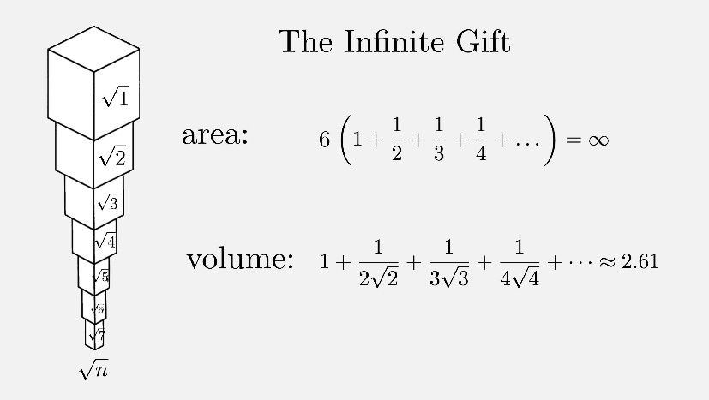I'm standing 5 m from a wall. I jump half the distance (2.5 m) towards the wall. I halve the distance again (1.25 m) and continue getting closer to the wall by stepping half the remaining distance each time. Do I ever reach the wall? Zeno, the 5th century BCE Greek philosopher, proposed a similar question in his famous Paradoxes (search for Zeno’s paradox).

The first known example of an infinite sum was when Greek mathematician Archimedes showed in the 3rd century BCE that the area of a segment of a parabola is 4/3 the area of a triangle with the same base. The notation he used was different, of course, and some of the approach was more geometric than algebraic, but his approach of summing infinitely small quantities was quite remarkable for the time.

Mathematicians Madhava from Kerala, India studied infinite series around 1350 CE. Among his many contributions, he discovered the infinite series for the trigonometric functions of sine, cosine, tangent and arctangent, and many methods for calculating the circumference of a circle

In the 17th century, James Gregory (1638-1675) worked in the new decimal system on infinite series and published several Maclaurin series. In 1715, a general method for constructing the Taylor series for all functions for which they exist was provided by Brook Taylor (1685-1731). Leonhard Euler (1707-1783) derived series for sine, cosine, exp, log, etc., and he also discovered relationships between them. He also introduced sigma notation (Σ) for sums of series.

**Infinite Series**

Let  be a given sequence. Then a sum of the form



is called an infinite series.

Another way of writing this infinite series is  or  or simply .

**Convergence and divergence of the series**

A series  is said to be convergent if the sequence , where , is convergent.

If the sequence  diverges then the series is said to be diverge.

**Remarks:**

For a series , the sequence , where , is called the sequence of partial sum of the series. The numbers  are called terms and  are called partial sums. One can note that





 and

 or .

If the sequence converges to *s,* we say that the series converges and write , the number *s* is called the sum or value of the series but it should be clearly understood that the ‘*s’* is the limit of the sequence of sums and is not obtained simply by addition.

Also note that the behaviors of the series remain unchanged by addition or deletion of the first finite terms. Just as a sequence may be indexed such that its first element is not  , but is  , or  or , we will denote the series having these numbers as their first element by the symbols

 or  or .

**Review:**

* Let  be a convergent sequence, then .

**Theorem**

If  converges then .

Proof

Assume that .

As  is convergent, therefore  is convergent.

Suppose , then we have .

Now we have  for ,

or  for .

Therefore 



. ❑

**Remark:**

(i) The converse of the above theorem is false. For example, consider the series . We know that the sequence , where , is divergent therefore  is divergent series, although .

(ii) The above theorem shows that if , then  is divergent (This is called basic divergent test).

**Examples:**

1. Is the series  is convergent or divergent?

*Solution.*

Assume .

Now we have .

Hence  is divergent (by basic divergent test)

1. Show that the series  is divergent.

*Solution.*

The above series can be written as .

Then take

,

As we have .

Hence the given series is divergent by basic comparison test.

1. Is the series  is convergent or divergent?

*Solution.*

Assume that .

As 

 for all .

We conclude  cannot be zero.

Hence  is divergent (by basic divergent test).

**Questions:**

1. Prove that if  is convergent then  but converse is not true.
2. Prove that if , then  is divergent.

**Review:**

* A series  is convergent if and only if it sequence of partial sum is convergent.
* A sequence in  is convergent iff it is Cauchy sequence.
* A sequence  is Cauchy sequence if and only if for all  there exists positive integer  such  for all  (or ).

**Theorem (General Principle of Convergence or Cauchy Criterion for Series)**

A series  is convergent if and only if for any real number , there exists a positive integer  such that

 

Proof

Assume that .

Then  is convergent if and only if  is convergent.

Now  is convergent if and only  is Cauchy sequence,

that is, for all real number , there exists a positive integer  such that

  ……… (*i*)

As , therefore



So by using (*i*), we have

 .

This gives

 . ❑

**Review:**

* A bounded and monotone sequence, then it is convergent.
* An unbounded sequence is divergent.

**Theorem**

Let  be an infinite series of non-negative terms and let  be a sequence of its partial sums. Then  is convergent if  is bounded and it diverges if  is unbounded.

Proof

We have , this give .

As we have given  for all  and  for all .

Therefore, the sequence  is monotonic increasing.

Now if  is bounded then we concluded that  is convergent.

Now if  is unbounded, then it is divergent.

Hence we conclude that  is convergent if  is bounded and it divergent if  is unbounded. ❑

**Review:**

* A series  is divergent if and only if there exists real number , such that for all positive integer ,

 whenever 

**Theorem (Comparison Test)**

Suppose  and  are infinite series such that ,  for all . Also suppose that for a fixed positive number  and positive integer ,

 .

(i) If  is convergent, then  is convergent.

(ii) If  is divergent, then  is divergent.

Proof

(i) Suppose  is convergent and

 , , …………. (*i*)

By Cauchy criterion; for any positive number  there exists  such that

 

from (*i*)

 ,   is convergent.

(ii) Now suppose  is divergent then there exists a real number , such that

 , .

From (*i*)

, 

 is divergent. ❑

**Example**

Prove that  is divergent.

Since  .



 is divergent as  is divergent. ❑

**Example**

The series  is convergent if  and diverges if .

Let .

If  then

 and .

Now 





 (replacing 3 by 2, 5 by 4 and so on.)



  



.

  ,

i.e. 

 is bounded and also monotonic. Hence, we conclude that  is convergent when .

If  then

 

 

Since  is divergent therefore  is divergent when . ❑

**Theorem (Limit Comparison Test)**

Let ,  and , where .

(i) If , then the series  and  behave alike.

(ii) If and if is convergent, then is convergent. If  is divergent then  is divergent.

Proof

Since , therefore for , there exists positive integer  such that

 . ………….. (*\** )

1. If , then take  (as  will be positive)

 .

 .

 .

 .

Then we got

 and  for .

Hence by comparison test we conclude that  and  converge or diverge together.

1. If , then (*) implies 

Hence by comparison test we conclude that  is convergent if  converges. Also  is divergent if diverges. ❑

**Example**

Is the series  is convergent or divergent for real ?

Consider  and take .

Then  



Applying limit as 

.

 and  have the similar behavior for all finite values of *x* except *x* = 0.

Since  is convergent series therefore the given series is also convergent for finite values of *x* except *x* = 0.

If , then the given series is also convergent because it is just zero. ❑

**Theorem (Cauchy Condensation Test)**

Let ,  for all  (i.e.  is positive term decreasing sequence). Then the series  and  converges or diverges together.

Proof

The condensation test follows from noting that if we collect the terms of the series into groups of lengths , each of these groups will be less than  by monotonicity. Observe,



We have use the fact that  is decreasing sequence. The convergence of the original series now follows from direct comparison to this "condensed" series. To see that convergence of the original series implies the convergence of this last series, we similarly put,



And we have convergence, again by direct comparison. And we are done. Note that we have obtained the estimate

 ❑

**Example**

Find value of *p* for which  is convergent or divergent.

If  then , therefore the series diverges when .

If  then the condensation test is applicable, and we are lead to the series





.

Now  iff  i.e. when .

And the result follows by comparing this series with the geometric series having common ratio less than one.

The series diverges when  ( i.e. when ).

The series is also divergent if  ❑

**Example**

Prove that if ,  converges and if  the series is divergent.

Since  is increasing, therefore  decreases

and we can use the condensation test to the above series.

We have 

 

Now .

This converges when  and diverges when . ❑

**Example**

Prove that  is divergent.

Since  is increasing there  decreases.

We can apply the condensation test to check the behavior of the series.

Take , then .

So  .

Since  

and  is diverges therefore the given series is also diverges. ❑

**Alternating Series**

A series in which successive terms have opposite signs is called an alternating series.

**Example:**

 is an alternating series.

**Review:**

* If  is convergent to , then every subsequence of  converges to .
* If  is convergent, then .
* If a sequence is decreasing and bounded below then it is convergent.

**Theorem (Alternating Series Test or Leibniz Test)**

Let  be a decreasing sequence of positive numbers such that  then the alternating series  converges.

Proof

Looking at the odd numbered partial sums of this series we find that

.

Since  is decreasing therefore all the terms in the parenthesis are non-negative

 .

Moreover





Since  therefore .

Hence the sequence of odd numbered partial sum is decreasing and is bounded below by zero. (as it has +ive terms)

It is therefore convergent.

Thus  converges to some limit  (say).

Now consider the even numbered partial sum. We find that



and



  .

so that the even partial sum is also convergent to .

 both sequences of odd and even partial sums converge to the same limit.

Hence, we conclude that the corresponding series is convergent. ❑

**Absolute Convergence**

A series  is said to converge absolutely if  converges.

**Review:**

* A series is convergent if and only if for any real number , there exists a positive integer  such that  for all .
* For all , ; .

**Theorem**

An absolutely convergent series is convergent.

Proof:

If  is convergent then by Cauchy criterion for convergence; for a real number , there exists a positive integer  such that

 . ………….. (i)

Also, we have

 ……………….. (ii)

By using (i) and (ii), one has

 .

This implies the series  is convergent.

***Note:***

The converse of the above theorem does not hold.

e.g.  is convergent but  is divergent. ❑

**Question:**

* Prove that every absolute convergent series is convergent, but convers is not true in general.

**Review**

* Let  and . Then there exist number  such that .
* If  exists and , , then there exist positive integer  such that  for .

**Theorem (The Root Test)**

Let .

Then  converges absolutely if  and it diverges if .

Proof

Let  then there exist real number  such that .

As we have , there is some  so that

 

 .

Since  is convergent because it is a geometric series with , therefore  is convergent.

 converges absolutely.

Now let . Also we have , there is some  so that

 for .

 for .

 .

 is divergent. ❑

***Note:***

The above test gives no information when .

e.g. Consider the series  and .

For each of these series; , but  is divergent and  is convergent.

**Theorem (Ratio Test)**

The series 

(i) Converges if . (ii) Diverges if .

Proof

If (i) holds we can find  and integer *N* such that

 for 

In particular









…………………….

…………………….

…………………….



 we put .

i.e.  for .

Sine  is convergent because it is geometric series with common ratio less than 1, therefore  is convergent (by comparison test).

If (ii) holds, then we can find integer  such that

 for .

This gives

 for ,

that is, the terms are getting larger and guaranteed to not be negative, therefore

. This provide us .

 is divergent. ❑

***Note:***

The knowledge  implies nothing about the convergent or divergent of series.

**Example**

Prove that series  with  is divergent.

Since , therefore  .

Also 

 





    .

This implies the given series is divergent. ❑

**Dirichlet’s Theorem**

Suppose that

(i) ,  is bounded and

(ii)  be positive term decreasing sequence such that .

Then  is convergent.

Proof

Since  is bounded, therefore, there exists a positive number  such that

 .

Then  for 









Since  is positive term decreasing,

therefore 



 



 .

, where  a certain number

 The  is convergent. (We have use Cauchy criterion here.) ❑

**Theorem**

Suppose that

(i)  is convergent and

(ii)  is monotonic convergent sequence,

then  is also convergent.

Proof

Suppose  is decreasing and it converges to .

Put  for all .

  and .

Since  is convergent,

therefore ,  is convergent, that is,  is bounded.

By Dirichlet’s theorem, we have  is convergent.

Since  and  and  are convergent,

therefore  is convergent.

Now if  is increasing and converges to *b* then we shall put . ❑

**Example**

A series  is convergent if  and divergent if .

To see this we proceed as follows



Take  

 



Since  is convergent when  and  is decreasing for  and it converges to 0. Therefore  is convergent

 is also convergent.

Now  is divergent for  therefore  diverges for . ❑

**Example**

To check  is convergent or divergent.

We have 

Take  

 

 is divergent although  is decreasing, tending to zero for  therefore  is divergent.

 is divergent.

The series also divergent if .

i.e. it is always divergent. ❑

***References:***

[1] Principles of Mathematical Analysis by Walter Rudin (McGraw-Hill, Inc.)

[2] Introduction to Real Analysis by R.G.Bartle, and D.R. Sherbert (John Wiley & Sons, Inc.)

[3] Mathematical Analysis by Tom M. Apostol, (Pearson; 2nd edition.)

[4] Real Analysis by Dipak Chatterjee (PHI Learning, 2nd edition.)

*Chapter 04*

# Limit & Continuity

Limits define where we're headed, and continuity ensures the journey there is smooth --- **Dr. Ben Carter, Data Scientist**

In this chapter we will introduce the important notion of the limit of a function. The intuitive idea of the function *f* having a limit *L* at the point *a* is that the values *f*(*x*) are close to *L* when *x* is close to (but different from) *a*. But it is necessary to have a technical way of working with the idea of "close to" and this is accomplished in the  definition given below.

In order for the idea of the limit of a function *f* at a point *a* to be meaningful, it is necessary that *f* be defined at points near *a*. It need not be defined at the point *a*, but it should be defined at enough points close to *a* to make the study interesting. This is the reason for the following definition.

❖ **LIMIT OF THE FUNCTION**

***Definition:*** Suppose  and  be a function. A number  is called the limit of  when  approaches to *a* if for all , there exists  (depending upon ) such that

 whenever .

***Notation:*** It is written as .

***Note:***  *i*) It is to be noted that  but that *a* need not a point of  in the above definition (*a* is a limit point of  which may or may not belong to .)

*ii*) Even if , we may have .

***Example:***

In the following diagram we have illustrated .

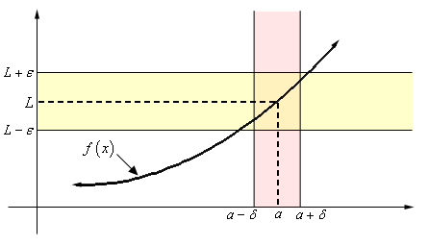

What the definition is telling us is that for any number  that we pick we can go to our graph and sketch two horizontal lines at  and  as shown on the graph above. Then somewhere out there in the world is another number , which we will need to determine, that will allow us to add in two vertical lines to our graph at  and .

**❖ *Example***

1. Consider the function , .

It is to be noted that  is not defined at  but if  and is very close to 1, then  is close to 2.

To check limit of  as , let’s start off by letting  be any number then we need to find a number  so that the following will be true.

 whenever .

We’ll start by simplifying the left inequality in an attempt to get a guess for . Doing this gives,

 implies . ❑

1. Lets see by definition: .

Let’s start off by letting  be any number then we need to find a number  so that the following will be true.

 whenever .

We’ll start by simplifying the left inequality in an attempt to get a guess for . Doing this gives,

 implies . ❑

**Note:** Today, we have developed lot of tools to find the limit of functions without using the definition (even without knowing the limit). Here our aim is to understand the limit by definition.

If the definition of limit is violated or leads to something absurd even by choosing one value of , then we say limit doesn’t exist.

**❖ *Example***

 does not exist.

Suppose that  exists and take it to be *l*, then there exist a positive real number  such that

 when  (we take here )

We can find a positive integer  such that

 then  and .

It thus follows

 

and   or .

So that



.

This is impossible; hence limit of the function does not exist. ❑

**❖ *Example***

Consider the function  defined as



Show that , where  does not exist.

*Solution*

On the contrary, suppose that 

Then for given  we can find  such that

 whenever .

Consider two points  and  from interval  such that  is rational and  is irrational.

Then  & .

Now





 (since ).

.

i.e. 

In particular, if we take , then .

This is absurd.

Hence the limit of the function does not exist. ❑

**❖ *Theorem***

If  exists, then it is unique.

*Proof*

Suppose  is not unique.

Take  and , where .

So for , there exists real numbers  and  such that

 whenever 

&  whenever .

Now 



, whenever .

That is,  for all .

 or  . ❑

❖ **RIGHT HAND LIMIT OF THE FUNCTION**

***Definition:*** Suppose  and  be a function. If for all , there exists  (depending upon ) such that

 whenever ,

Then *L* is called right hand limit of function *f* at *a*.

***Notation:*** It is written as .

❖ **LEFT HAND LIMIT OF THE FUNCTION**

***Definition:*** Suppose  and  be a function. If for all , there exists  (depending upon ) such that

 whenever ,

Then *L* is called left hand limit of function *f* at *a*.

***Notation:*** It is written as .

**Remark:** One can easily prove that if the right hand limit or left hand limit of the function exists then it is unique.

**Examples:**

(i) Consider a function  for .

It is easy to see that  but 

(ii) Suppose



To compute , we use the part of the definition for *f* which applies to , so



To compute , we use the part of the definition for *f* which applies to , so



Note that  but . ❑

The proof of the following theorem can be seen in FSc or BSc mathematics book.

**❖ *Theorem***

Suppose  is a function define on *E* may not containing point *a*. Then

.

**❖ LIMIT AS A INFINITY**

***Definition:***Let  be a function defined on an interval that contains , except possibly at . Then we say that



if for every number , there is some number  such that

 whenever .

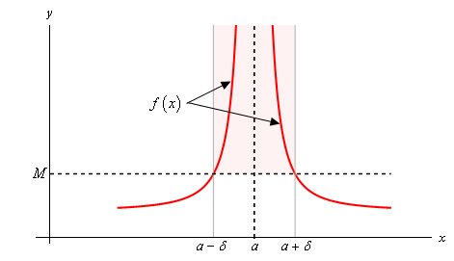Above definitions is telling us that no matter how large we choose *M* to be we can always find an interval around , given by  for some number , so that as long as we stay within that interval the graph of the function will be above the line  as shown in the graph.

Similarly, one can define limit as negative infinity.

**❖ LIMIT AS NEGATIVE INFINITY:**

***Definition:*** Let  be a function defined on an interval that contains , except possibly at . Then we say that



if for every number , there is some number  such that

 whenever .

**❖ *Example***

Use the definition of the limit to prove the following limit.

.

***Solution:***

Let  be any number and we’ll need to choose a  so that,

 whenever .

We take

 

. ❑

**Exercise:** Given the following graph of function :

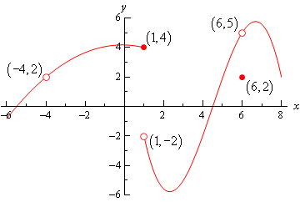

(a)  (b)  (c)  (d) 

(e)  (f)  (g)  (h) 

(i)  (j)  (k)  (l) 

**❖ LIMIT AT INFINITY**

***Definition:***Let  and  be subsets of . A function  is said to tend to limit  as , if for a real number  however small, there exists a positive number  which depends upon  such that distance

 when .

***Notation:*** This is written as .

Above definition tells us that no matter how close to *L* we want to get, mathematically this is given by  for any chosen  , we can find another number *M* such that provided we take any *x* bigger than *M*, then the graph of the function for that *x* will be closer to *L* than  and .

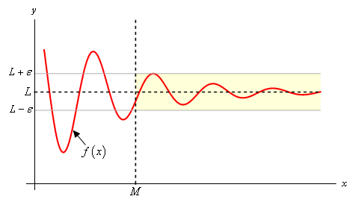

Similarly, one can define limit at negative infinity.

**❖ LIMIT AT NEGATIVE INFINITY**

***Definition:***Let  and  be subsets of . A function  is said to tend to limit  as , if for a real number  however small, there exists a positive number  which depends upon  such that distance

 when .

***Notation:*** This is written as .

**❖ *Example***

By definition, prove that .

We have  .

Now if  is given we can find  so that

 whenever . ❑

The following theorem is very useful to find the limit of different function. Here we are not giving the proof as one can found it in the mathematics book of FSc.

**❖ *Theorem***

Let  and  be real valued functions. If  and  then

i- ,

ii- ,

iii- , provided .

**❖ CONTINUITY**

***Definition*:** Suppose  and  be a function. Then  is said to be continuous at  if for every  there exists a  such that

 for all points  for which .

***Definition*:** If  is continuous at every point of , then  is said to be continuous on .

***Note:*** Comparing the definition of continuity with the definition of the limit, It is to be noted that  has to be continuous at  iff .

**❖ *Examples***

A function  is continuous for all .

Here . Take  and .

Then we have to show

  whenever .

Now 





Now if , then we have



Since  is arbitrary real number,

therefore, the function  is continuous for all real numbers. ❑

**❖ *Example***

A function  is continuous on .

Let  be an arbitrary point such that 

For , we have



 

 whenever 

i.e. 

 is continuous for .

 is an arbitrary point lying in 

 is continuous on  ❑

**❖ RIGHT CONTINUOUS AND LEFT CONTINUOUS**

***Definition*:** Let be a real valued function. It is said to be right continuous at point *a* if  and it is said to be left continuous at point *a* if .

**❖ *Example***

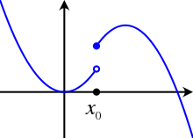

Consider a function given in above graph. We see  is not continuous at point . It is right continuous at point  but not left continuous at point .

**❖ *Example***

Let



Then  is left continuous at  but it is not right continuous at 2.

**❖ RIGHT CONTINUOUS AND LEFT CONTINUOUS**

***Definition*:** A function  is said to be continuous on closed interval  if

 is continuous on 

 is right continuous at .

 is left continuous at .

**❖ *Theorem (The intermediate value theorem)***

Suppose  is continuous on  and , then given a number  that lies between  and , there exist a point  with .

*Proof*

Without loss of generality, we can consider  and .

Also let . Then  is non-empty as  and  is an upper bound of 

Since we are dealing with the set of real numbers, therefore supremum of  exist in , say .

Since  is continuous on , in particular at , therefore for all  there exists  such that

 whenever .

This means that

 for all  between  and 

By the properties of the supremum, there exist **  between *c* − *δ* and *c* that is contained in *S,* so that

. ………….. (i)

Choose ** between *c* and *c* + *δ.* Then , so we have

 …………. (ii)

From (i) and (ii), we have for all ,

.



So ultimately, we have . ❑

**❖ UNIFORM CONTINUITY**

***Definition:*** Suppose  is a real valued function. We say that  is uniformly continuous on  if for every  there exists  such that

   for which .

The uniform continuity is a property of a function on a set, that is, it is a global property but continuity can be defined at a single point i.e. it is a local property.

Uniform continuity of a function at a point has no meaning.

It is evident that every uniformly continuous function is continuous.

To emphasize a difference between continuity and uniform continuity on set , we consider the following examples.

**❖ *Example***

Let  be a half open interval  and let  be defined for each  in  by the formula . It is uniformly continuous on . To prove this, assume  and take







If  then 

Hence if  is given we need only to take  to guarantee that

 for every pair  with 

Thus  is uniformly continuous on the set . ❑

**❖ *Example***

Let  be the half open interval  and let a function  be defined for each  in  by the formula . This function is continuous on the set , however we shall prove that this function is not uniformly continuous on .

***Solution***

Let suppose  and suppose we can find a  , , to satisfy the condition of the definition.

Taking  , , we obtain



and



Hence for these two points we have .

This contradict the definition of uniform continuity.

Hence the given function being continuous on a set  is not uniformly continuous on . ❑

***References:*** *(1) Principles of Mathematical Analysis*

*Walter Rudin (McGraw-Hill, Inc.)*

*(2) Introduction to Real Analysis*

*R.G.Bartle, and D.R. Sherbert (John Wiley & Sons, Inc.)*

*(3) Mathematical Analysis,*

*Tom M. Apostol, (Pearson; 2nd edition.)*

*(4) Elementary Real Analysis*

*B.S. Thomson, J.B. Brickner, A.M. Bruckner*

*(ClassicalRealAnalysis.com; 2nd Edition)*

*(5) Paul's Online Notes*

*http://tutorial.math.lamar.edu/*

*Chapter 05*

# Differentiation

Differentiation: the art of knowing the next step, precisely --- **Dr. Ben Carter, Data Scientist**

Differentiation allows us to find rates of change. For example, it allows us to find the rate of change of velocity with respect to time (which is acceleration). Calculus courses succeed in conveying an idea of what a derivative is, and the students develop many technical skills in computations of derivatives or applications of them. We shall return to the subject of derivatives but with a different objective.

Now we wish to see a little deeper and to understand the basis on which that theory develops.

Let *f* be defined and real valued on . For any point , form the quotient

.

We fix point  and study the behaviour of this quotient as .

**❖ DERIVATIVE OF A FUNCTION**

***Definition:*** Let *f* be defined on an open interval , and assume that. Then *f* is said to be differentiable at *c* whenever the limit



exists. This limit is denoted by  and is called the derivative of *f* at point *c*.

***Definition*:** If *f* is differentiable at each point of , then we say *f* is differentiable on .

**❖ *Remarks***

* There are so many notations to represents the derivative of the function in the literature.
* If, then we have



**❖ *Example***

(*i*) A function  defined by



This function is differentiable at  because

  

 .

(*ii*) Let  ;  (*n* is integer), .

Then

 





.

This implies that *f*  is differentiable every where and .

**❖ *Theorem*** (Differentiability implies continuity)

Let *f* be defined on , if *f* is differentiable at a point , then *f* is continuous at *x*.

*Proof*

We know that

, where  and .

Now







.

This show that *f* is continuous at *x*. ❑

**❖ *Remarks***

(*i*) The converse of the above theorem does not hold.

Consider 

Then  does not exists but  is continuous at .

(*ii*) If *f* is discontinuous at some point of the domain of the function then  does not exist. e.g.



A function *f* is discontinuous at  therefore it is not differentiable at .

**❖ *Question***

Prove that a differentiable function is continuous, but the converse is not true.

**❖ *Theorem***

Suppose  and  are defined on  and are differentiable at a point , then ,  and  are differentiable at *x* and

(*i*) ,

(*ii*) ,

(*iii*) , proved .

The proof of this theorem can be get from any F.Sc or B.Sc textbook.

**❖ *Remark***

As we know , this gives

,

where  is a function such that  as .

This gives us , where  as , as an alternative definition of derivative.

**❖ *Theorem (Chain Rule)***

Suppose  is continuous on ,  exists at some point . A function  is defined on an interval  which contains the range of , and  is differentiable at the point . If  ; , then  is differentiable at  and

.

***Proof***

Let .

By the definition of the derivative, we have

 ………... (*i*)

and  ……….. (*ii*)

where ,  and  as  and  as .

Let us suppose . Then



 by (*ii*)



 by (*i*)

or if 

,

taking the limit as  we have



, 

This is the required result. ❑

**❖ *Example***

Let us find the derivative of , One way to do that is through some trigonometric identities. Indeed, we have



So we will use the product formula to get



which implies



Using the trigonometric formula , we have



Once this is done, you may ask about the derivative of ? The answer can be found using similar trigonometric identities, but the calculations are not as easy as before. We will see how the Chain Rule formula will answer this question in an elegant way.

Let us find the derivative of 

We have  , where  and  . Then the Chain rule implies that  exists and



**❖ *Maxima and Minima of Functions***

Maxima and minima of a function are the largest and smallest value of the function respectively either within a given range or on the entire domain. Collectively they are also known as extrema of the function. The maxima and minima are the respective plurals of maximum and minimum of a function. Before understanding maxima and minima in detail, let’s understand the local maximum and minimum value of the function first.

**❖ LOCAL MAXIMUM**

***Definition:*** Let  be a real valued function defined on a set , we say that  has a local maximum at a point  if there exist  such that  for all  with .

Local minimum is defined likewise.

**❖GLOBAL (OR ABSOLUTE) MAXIMUM AND MINIMUM**

***Definition:*** The maximum or minimum over the entire domain of the function is called an "global" or "absolute" maximum or minimum.

**❖ *Remark:*** There might be only one global maximum (and one global minimum) but there can be more than one local maximum or minimum.

**❖ *Theorem***

Let  be defined on  and it is differentiable on . If  has a local maximum at a point  and if  exist, then .

***Proof***

Choose a  such that



Now if  then

.

Taking limit as  we get

 …………. (*i*)

If , then



Again, taking limit when  we get

 ……………. (*ii*)

Combining (*i*) and (*ii*) we have . ❑

**❖ *Theorem***

Let  be defined on  and it is differentiable on . If  has a local minimum at a point  and if  exist then .

The proof of this theorem is like the proof of above theorem.

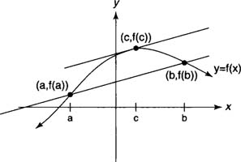**❖ *Lagrange’s Mean Value Theorem.***

Let  be continuous on and differentiable on . Then there exists a point  such that

.

***Proof.***

Let us design a new function

 ,

then clearly .

Since  depends upon  and  therefore it possesses all the properties of .

Now there are two cases:

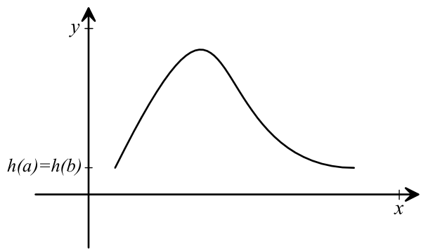i)  is a constant.

implies that  .

ii)  is not a constant, then

if  for some ,

then there exists a point  at which 

attains its maximum implies that .

case when *h*(*t*) < *h*(*a*).

and if 

then there exists a point  at which 

attain its minimum implies that .

Since ,

therefore .

This gives that  as desired. ❑

**❖ *Generalized Mean Value Theorem***

If  and  are continuous real valued functions on closed interval  and  and  are differentiable on , then there is a point  at which

,

***Proof.***

Let

 

Since  involves  and  therefore  is

i) continuous on close interval .

ii) differentiable on open interval .

iii) and .

To prove the theorem, we have to show that  for some .

There are two cases to be discussed:

(*i*) If  is constant function, then  .

(*ii*) If  is not constant, then

if  for some ,

then there exists a point  at which  attains its maximum,

this implies that ,

and if  for some ,

then there exists a point  at which  attain its minimum,

this implies that .

Hence



This gives the desire result. ❑

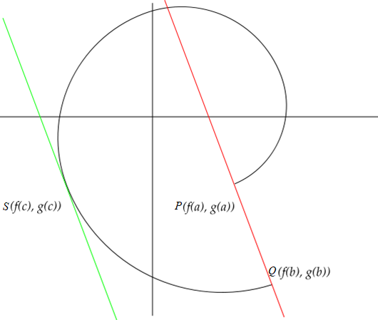***❖ Geometric interpretation of generalized MVT***

Consider a plane curve  represented by

, .

Then generalized mean value theorem (MVT) states that there is a point  on  between two points  and  of  such that the tangent at  to the curve  is parallel to the chord .

**❖ *Theorem (Darboux’s Theorem)***

Suppose  is a real differentiable function on some interval  with  and suppose  is a number between and  then there exist a point  such that .

***Proof***

Without loss of generality assume that .

Also assume that  for .

Then 

 If  we have

.

Since , therefore .

This implies that  is monotonically decreasing at .

So there exists a point  such that .

Similarly,



*a   b*

Since , therefore.

This implies that  is monotonically increasing at .

So there exists a point  such that 

This implies the function attain its minimum on  at a point  (say)

such that  

. ❑

**❖ *Question***

Let  be defined for all real *x* and suppose that  for all real  and . Then prove that  is constant.

***Solution***

Since ,

Therefore

.

Dividing throughout by  for , we get

 when 

and

 when 

Taking limit as , we get



This shows that function is constant.

**❖ *Question (L’Hospital Rule)***

Suppose  exist,  and .

Prove that  .

*Proof*

 





 .

……………………………

*Chapter 06*

# Riemann Integrals

It is through logic that we prove, but through intuition that we discover. The Riemann integral, at its heart, is an intuitive leap in quantifying accumulation.

We assume that the reader is familiar at least informally with the integral from a calculus course (FSc or BSc). In addition, they know about integrating a function on an interval  and know few of its interpretation as the "area under the graph", or its many applications to physics, engineering, economics, etc. Here our aim is to focus on the purely mathematical aspects of the integral. However, we first recall some basic terms that will be frequently used (see [1]).

***Partition***

Let  be a given interval. By a partition  of , we mean a finite set of points , where

.

The points of *P* are used to divide  into  non-overlapping subintervals

.

Each sub-interval is called a *component* of the partition.

Obviously, corresponding to different choices of the points  we shall have different partition.

The maximum of the length of the components is defined as the *norm* of the partition and it is denoted by , that is,

.

***Examples***

Consider an interval  and following partitions of this interval.

,

,



and more generally for any positive integer *n*, we can write

.

Also note that , , , .

***Refinement of a Partition***

Let  and  be two partitions of an interval  such that  i.e.  contains all the points of  and possibly some other points as well. Then  is said to be a *refinement* of .

***Example***

Note that  is refinement of .

***Remark***

 Note that if  implies, that is, refinement of a partition decreases its norm but the convers does not necessarily hold.

-----------------------------------------------------------------------------------------------------------

* How many partition can be made for any closed interval ?
* Can you write two different partitions of  with same norm?
* Can you write two partitions  and  of  such that  but .

-----------------------------------------------------------------------------------------------------------

***Riemann Integral***

 Let  be a real-valued function defined and bounded on . Corresponding to each partition  of , we put

 

 

We define upper and lower sums as



and ,

where .

Now we define , ………….… (*i*)

, ……………..(*ii*)

where the infimum and the supremum are taken over all partitions  of  . Then  and  are called the upper and lower Riemann integrals of  over  respectively.

In case the upper and lower integrals are equal, we say that  is Riemann integrable on  and we write , where  denotes the set of Riemann integrable functions over .

The common value of and  is denoted by  or by .

Which is known as the Riemann integral of  over .

**Exercises**

1. Let  be partition of  and  be function defined by . Find  and .
2. Let  be partition of  and  be function defined by . Find  and .

-----------------------------------------------------------------------------------------------------------

* If a function  is increasing on , then  and .
* If a function  is decreasing on , then what about its maximum and minimum value over interval .
* Let  be bounded on interval . Can you guess its maximum and minimum value over interval .

-----------------------------------------------------------------------------------------------------------

***Theorem***

The upper and lower integrals are defined for every bounded function  over interval .

***Proof***

Since  is bounded on , so its supremum and infimum values exist over .

Take  and  to be the maximum and minimum value of  in  respectively, that is,

 

Let  and  denote the supremum and infimum of  in  for certain partition  of  respectively. Then

 and  .

This gives

 



But ,

.

This gives

. ……. (i)

Similarity one can have

. ……. (ii)

Also we have  ……. (iii)

Combining (i), (ii) and (iii), we have



This shows that the numbers  and  form a bounded set over all the partitions of .

This gives the upper and lower integrals are defined for every function  over interval.

***Remark:*** In mathematics, different author approached to Riemann integral with the same ideas but slightly different than above e.g. see [2] and [3].

***Theorem***

If  is a refinement of , then following holds:

1. ,
2. .

***Theorem***

Let  be a real and bounded function defined on . Then

 i.e. .

***Theorem (Condition of Integrability or Cauchy’s Criterion for Integrability.)***

A function  if and only if for every . there exists a partition  such that .

***Theorem***

If , then  and

.

***Theorem (Fundamental Theorem of Calculus)***

If  and if there is a differentiable function  on  such that , then

.

**Theorem**

Suppose  is bounded on ,  has only finitely many points of discontinuity on . Then .

-----------------------------------------

**References:**

1. Walter Rudin, Principles of mathematical analysis. Vol. 3. New York: McGraw-hill, 1964.
2. Bartle, Robert Gardner, and Donald R. Sherbert. Introduction to real analysis. Vol. 2. New York: Wiley, 2000.
3. Tom M. Apostol, Mathematical Analysis, 2nd Edition, MA: Addison-Wesley, 1974.

